DATE:9

ASSESSMENT-6

SUBTOTAL, STORE PROCEDURE:

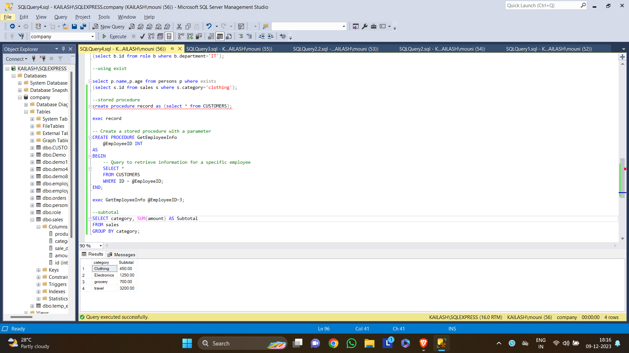

Database Schema

* A database schema is a structure that represents the logical storage of the data in a database.
* A database schema object includes the following:
* Consistent formatting for all data entries.
* Database objects and unique keys for all data entries.
* Tables with multiple columns, and each column contains its name and datatype.

DATABASE:

A database is a place to store information.

It can store the simplest data, such as a list of people as well as the most complex data.

Types of Database Schema

The database schema is divided into three types, which are:

* Logical Schema
* Physical Schema
* View Schema

DATABASE SCHEMA DESIGNS:

* Flat Model
* Hierarchical Model
* Network Model
* Relational Model
* Star Schema
* Snowflake Schema

PHYSICAL DATABASE SCHEMA:

Designing a database at the physical level is called a physical schema.

LOGICAL DATABASE SCHEMA:

The Logical database schema specifies all the logical constraints that need to be applied to the stored data.

VIEW SCHEMA:

The view level design of a database is known as view schema.

CREATING SCHEMA:

MySQL:

In MySQL, the "CREATE SCHEMA" statement creates the database. It is because, in MySQL, the CREATE SCHEMA statement is similar to CREATE DATABASE statement, and schema is a synonym for the database.